Name: __________________________________________ Date: _____________________________
Quadrilaterals – Rhombuses, Squares, Trapezoids & Kites

Definition: A rhombus is a parallelogram with four congruent sides.
A
B
C
D
If a parallelogram is a rhombus,
then it has 4 congruent sides.
If a parallelogram is a rhombus,  then its diagonals are perpendicular. |  |  | A  B  C  D
If a parallelogram is a rhombus,  then its diagonals bisect opposite angles. |  |  | A  B  C  D
opposite sides are parallel | opposite sides are congruent | opposite angles are congruent |  | consecutive angles are supplementary |  | diagonals bisect each other

Definition: A square is a parallelogram with 4 $≅$ sides & 4 right angles.
opposite sides are parallel | opposite sides are congruent |  | opposite angles are congruent |  |  | consecutive angles are supplementary |  | diagonals bisect each other
4 right angles |  |  |  | diagonals are congruent
4 congruent sides |  | diagonals are perpendicular |  |  |  |  | diagonals bisect  opposite angles
B
A

D
C

Definition: A trapezoid is a quadrilateral
with 1 pair of opposite sides parallel.
If a quadrilateral is a trapezoid, then it has one pair of opposite sides parallel. | A  B  C  D
If a trapezoid is isosceles, then its diagonals are congruent. | A  B  C  D
If a trapezoid is isosceles, then its base angles are congruent. | A  B  C  D
If a trapezoid is isosceles, then its non-base angles are supplementary. | A  B  C  D

Definition: A kite is a quadrilateral with
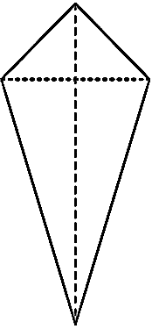
2 pairs of consecutive sides congruent.
A
B
C
D
If a quadrilateral is a kite, then it has 2 pairs of consecutive sides congruent.
A
B
C
D
If a quadrilateral is a kite, then it has 1 pair of opposite angles congruent.
A
B
C
D
If a quadrilateral is a kite, then it its diagonals are perpendicular.
If a quadrilateral is a kite, then it one diagonal is bisected by the other. | A  B  C  D

