Name: _____________________________________________ Date: ____________________________

|  |  |  |
| --- | --- | --- |
| **Term** | **Definition** | **Notation** |
|  | An exact position or location in a given plane. |  |
|  | The set of points between points A and B in a plane and the infinite number of points that continue beyond the points. |  |
|  | A flat, two-dimensional surface that extends infinitely far. |  |
|  | A line with two endpoints. |  |
|  | A line that starts at A, goes through B, and continues on. |  |
|  | Formed by 2 rays coming together at a common point (vertex) |  |

**Quick Geometry Vocabulary Review**

**Types of Angles**

|  |  |  |
| --- | --- | --- |
| **TYPE OF ANGLE** | **MEASUREMENT** | **SKETCH** |
| **ACUTE** |  |  |
| **RIGHT** |  |  |
| **OBTUSE** |  |  |
| **STRAIGHT** |  |  |

**Angle Vocabulary**

|  |  |  |
| --- | --- | --- |
| **Term** | **Definition** | **Sketch** |
| **Complementary** | Two angles whose sum is ______ |  |
| **Supplementary** | Two angles whose sum is ______ |  |
| **Congruent Angles** | Two or more angles with the _______ measure. |  |
| **Adjacent Angles** | Two angles with a common __________ and _________, but no _________________________________. |  |
| **Angle Bisector** | A ray (or line or segment) that divides an angle into two _______________ angles |  |
| **Vertical Angles** | Two angles are vertical angles  if their sides form two pairs of opposite rays.  **VERTICAL ANGLES ARE ____________________** |  |
| **Linear Pair** | Two adjacent angles are linear pairs  if their non-common sides are opposite rays.  **LINEAR PAIRS ARE _____________________** |  |
| **Angle Addition Postulate** | If B lies on the interior of <AOC,  then m<AOB + m<BOC = m<AOC. |  |

**Practice**

**2**

# M

**A**

**T**

**H**

Name an example of each of the following:

**1**

1. Line Segment: _______ A line: _______ A ray: _______
2. Name the angle represented with the number 1 using 3 letters. ___________
3. Why can’t you name angle 1, angle A? _________________________________________
4. Is angle 1 an obtuse, acute, or right angle? ________________
5. If angle 1 is 60 degrees, what is the measure of angle 2? ________________
6. Can two supplementary angles both be obtuse angles? Acute? Right?

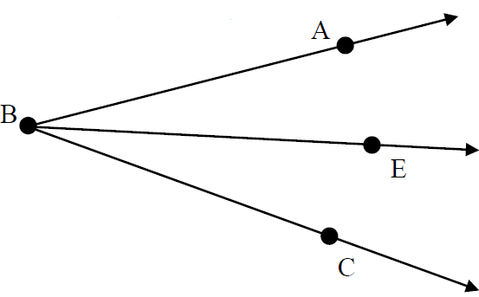

 is an angle bisector.

1. If m∠ABE = 40°, then m∠EBC = ____________.

1. If m∠ABC = 4x-12 & m∠ABE = 24°, then x = ____________.
2. and are complementary. Solve for x and the measure of both angles.

∠1 = 5x + 2

∠2 = 2x + 4

1. and are supplementary. Solve for x and the measure of both angles.

∠1 = 12x + 4

∠2 = 9x + 8

1. One of two complementary angles is 16 degrees less than its complement.

Find the measure of both angles.