Name: _______________________________________ Date: ________________________________

**Lines and Transversals**

* Two lines are **____________________** if they are coplanar and do not intersect.
* Lines that do not intersect and are not coplanar are called **_______________.**
* **_____________________________________** are two lines that intersect at a right angle.
* A **__________________** is a line that intersects two or more coplanar lines at different points.

**Corresponding Angles Postulate:**

* If two parallel lines are cut by a

transversal, then the pairs of

corresponding angles are congruent.

**Alternate Interior Angles Theorem:**

* If two parallel lines are cut by a

transversal, then the pairs of alternate

interior angles are congruent.

**Consecutive Interior/Exterior Angles Theorem:**

**(Same Side Interior/Exterior Angles)**

* If two parallel lines are cut by a

transversal, then the pairs of consecutive

interior angles are supplementary.

**Alternate Exterior Angles Theorem:**

* If two parallel lines are cut by a

transversal, then the pairs of alternate

exterior angles are congruent.

**Perpendicular Transversal Theorem:**

* If a transversal is perpendicular to

one of the two parallel lines, then it is

perpendicular to the other.

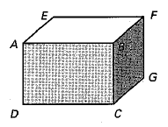**Think of each segment in the diagram as part of a line.**

**Identify the segments as parallel, skew, or perpendicular.**

1. 
2. 
3. 
4. 

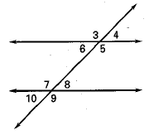

**Identify the angles as corresponding, alternate interior,**

**alternate exterior, or consecutive interior.**

1. ∠3 and ∠7
2. ∠4 and ∠10
3. ∠5 and ∠8
4. ∠8 and ∠6
5. ∠9 and ∠5
6. ∠5 and ∠7

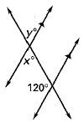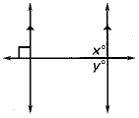

1. 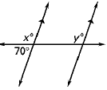

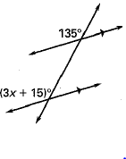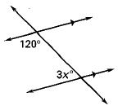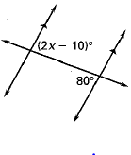



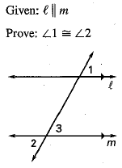

|  |  |
| --- | --- |
| **STATEMENT** | **REASON** |
|  |  |
|  |  |
|  |  |
|  |  |
|  |  |