Name ________________________________________­­­­­________ Date ____________________________

**UNIT 1 QUIZ REVIEW**

**Name the correct angle using the given picture.**

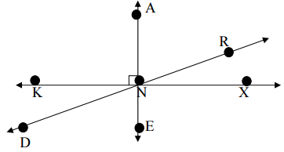

1.  and ________ are vertical angles.
2.  and ________ are complementary angles.
3.  and ________ are supplementary angles.

**Name the correct angle using the given picture.**

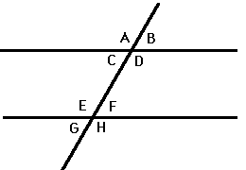

1.  and ________ are vertical angles.
2.  and ________ are alternate interior angles.
3.  and ________ are corresponding angles.
4.  and ________ form a linear pair.

**Lines k and n are parallel.**

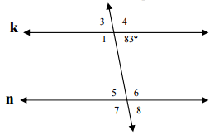

1.  = ______
2.  = ______
3.  = ______

**Find q and the angles based on the diagram to the right.**

1.  = ______

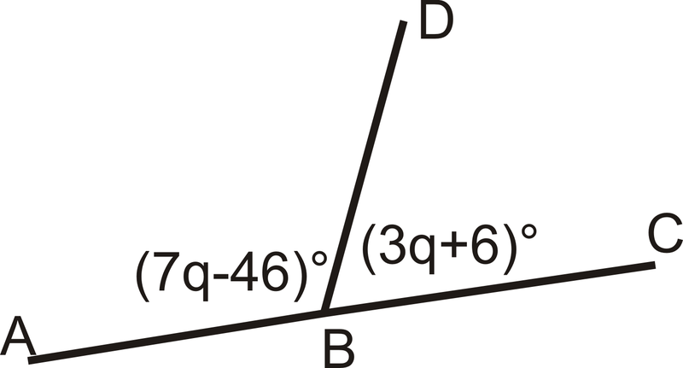

1.  = ______
2.  = ______
3. One angle is 50 more than its supplement. Find both angles.

**Solve for x.**

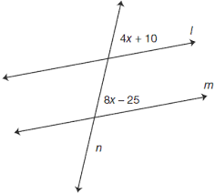

15. 16.

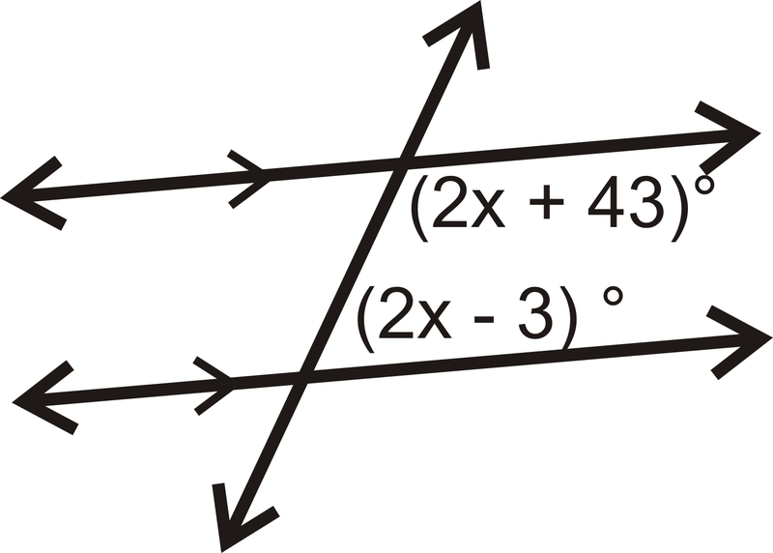

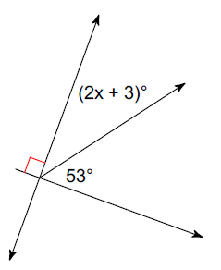

17. 18.

Graph the

Following:



**Given** , **Find the following angles.**



19. 

20. 

21. 

22. 