Name ________________________________________________________ Date _____________________________

**UNIT 2 TEST REVIEW**

**Congruent Triangles:** Determine whether each pair of triangles are congruent (SSS, SAS, ASA, AAS, or HL). If not, write not congruent. If they are congruent, write a congruence statement.

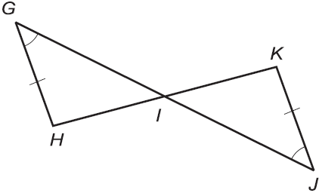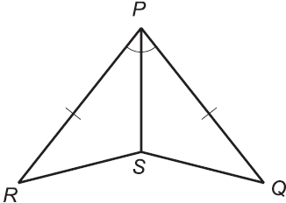1.  2.  3. 

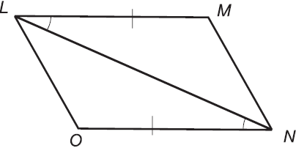

4.  5.  6. 

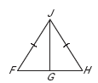

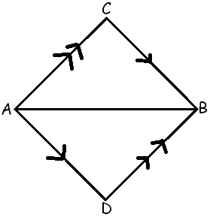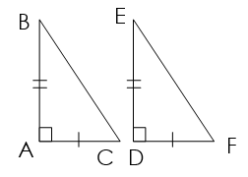

**Congruent Triangles:** Write the congruence statement for each pair of triangles.

7.  8. 

**O**

**G**

**R**

**A**

**C**

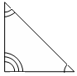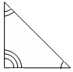

B

O

X

F

O

X

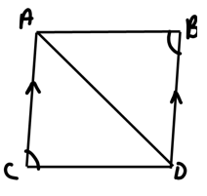**Proofs:** Complete the following proofs.

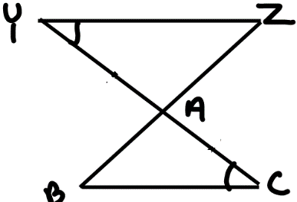9. 10.

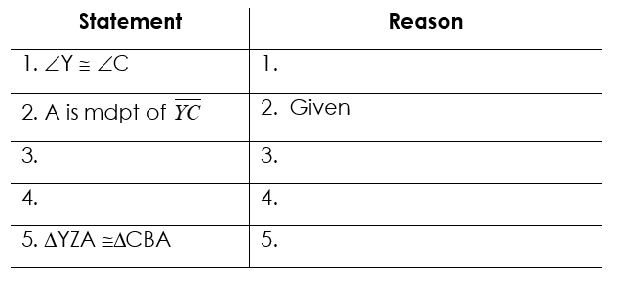

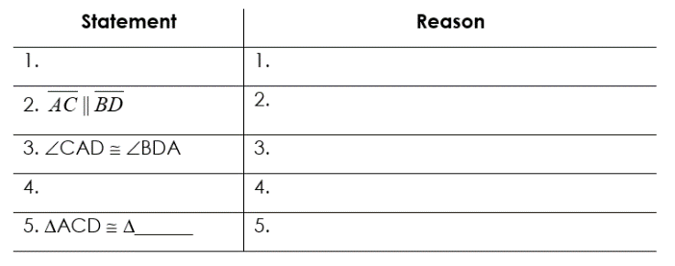

**Missing Information:** State what additional information (Sides or Angles) is required to know that the triangles are congruent for the reason given. **Hint: Mark the drawing!**

1. ASA;  12. AAS;  13. HL; 

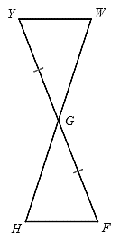

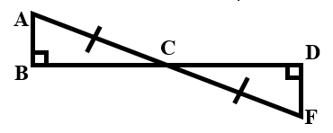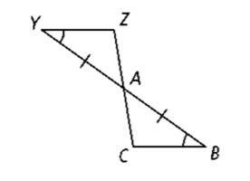

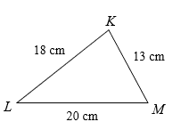**Triangle Theorems:** Use your knowledge of triangle theorems to complete the following.

14. List the angles from smallest to biggest.

15. Show how you know that the following lengths can make a triangle: 9, 14, 22.

**Free Response:** Solve. Show all work.

16. Find the value of x. 17. Solve for x.

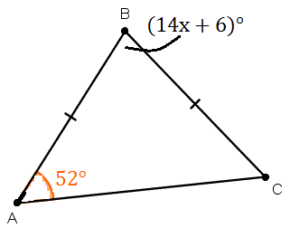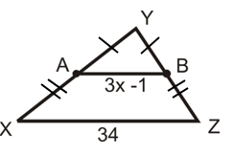

18. Solve for x. 19. Find the missing segment.

