Name: ________________________________________ Date: ____________________________________

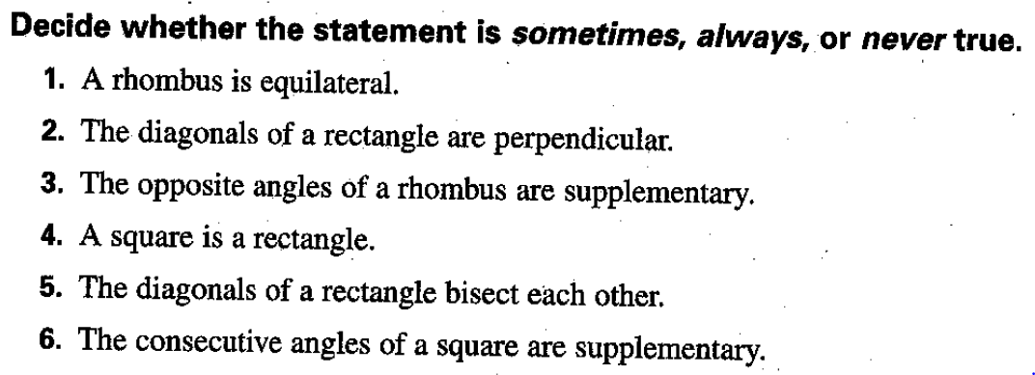

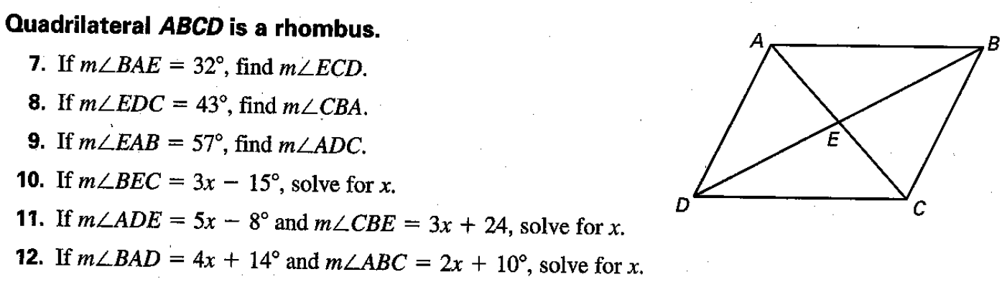

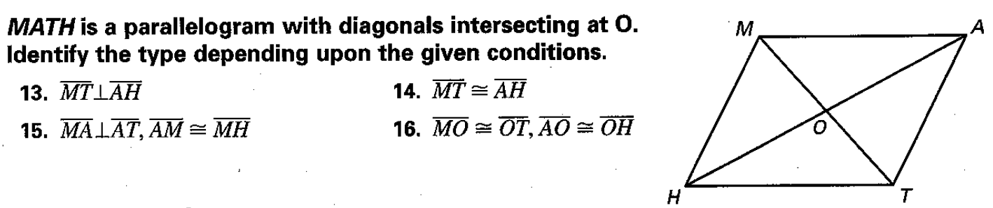

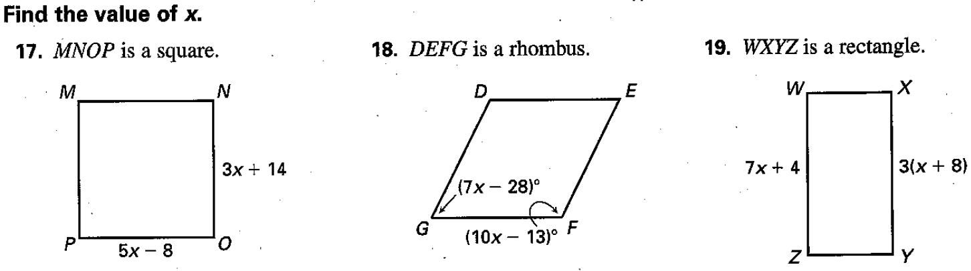

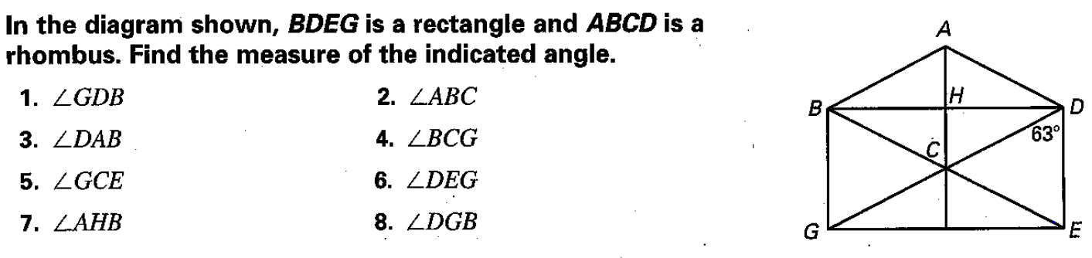

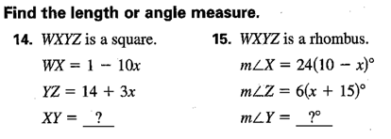

Challenge Section:

