UnWrapping the Unit Circle Activity – The Sine Curve

- Construct the diagram below using the circle that was given to you.
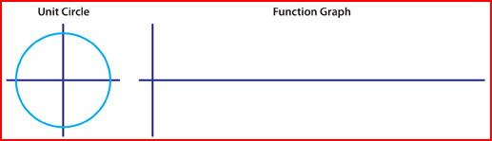
- Place wiki sticks around the unit circle (starting at 0°) and go around the entire circumference of the circle. Make sure you are wrapping it counterclockwise around the circle. Put a mark on the wiki stick at each angle mark.

- Next, transfer the marks on the wiki sticks onto the x-axis of the function graph. The end of the wiki stick that was at 0° must be placed at the origin of the function graph. Label these marks on the x-axis with the related angle measures from the unit circle (e.g., 0°, 30°, 45° etc.).

- Do the x-values on your triangle represent the cosine or the sine on the function? ____________________

- Do the y-values on your triangle represent the cosine or the sine on the function? ____________________

- Take a wiki stick and measure the radius of your circle. Bend the wiki stick to represent the radius. Use the length of your “bent” wiki stick to mark one unit above and below the origin on the y-axis of the function graph. Label these marks 1 and –1, respectively.

- Read this and see the diagram below: Cut a wiki stick to the length of the vertical leg of this triangle from the 30° mark on the circle to the x-axis. Let this wiki stick represent the y-value for the point on the function graph where x = 30°. Place the wiki stick appropriately on the function graph and make a dot at the top of it. Note: Since this point is above the x-axis in the unit circle, the corresponding point on the function graph should also be above the x-axis.
Example of transferring the wiki stick for the triangle drawn to the 60° mark
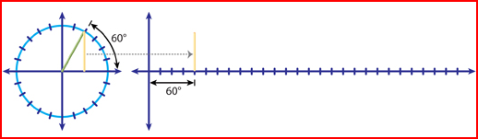

- Continue transferring lengths for all marks on the unit circle. Label the function graph you just created on your paper

What is the period (wavelength) of the sine curve? That is, after how many degrees before the graph starts to repeat? | What are the zeroes of this function? (Remember: The x-values are measuring angles and zeroes are the x-intercepts)
What are the x-values at the max and min of this function? | What are the y-values at the maxima and minima?

