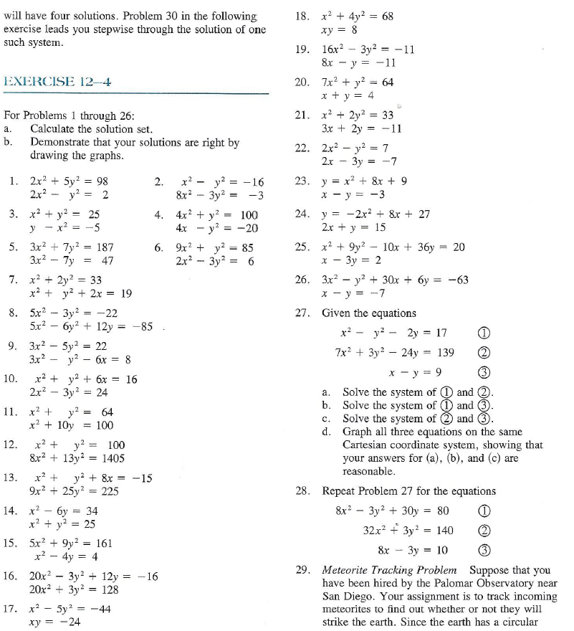
7.7 – Systems of Quadratics

