Name _________________________________________________ Date _______________________

**Day 2 – Proving Triangles Similar**

**Explain why the triangles are similar (SSS~, SAS~, or AA~) and write a similarity statement.**

1. RQS~__________ by ______
2. ABC~__________ by ______
3. ADE~__________ by ______

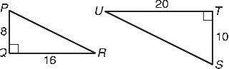4) QPR~__________ by ______

1. 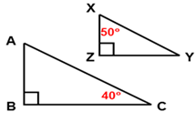ABC~__________ by ______

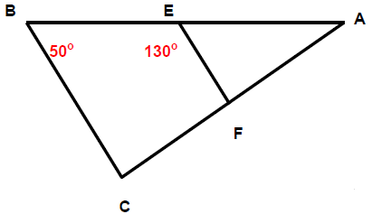6) AEF~__________ by _____

**Explain why the triangles are similar (SSS~, SAS~, or AA~) and find each length.**

9) Similar by ______ and **GK** = _____

10) Similar by ______ and **SU** = _____

11) Similar by ______ and **DE** = ____

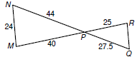12) Similar by ______ and **RQ** = ____