Name ___________________________________________________ Date __________________________________

**UNIT 3 QUIZ REVIEW**

1. Draw triangle T’L’C’ using a k=2

to construct a model of $∆$ TLC.

T(0, 2) → T’(_________)

L(1, 2) → L’(_________)

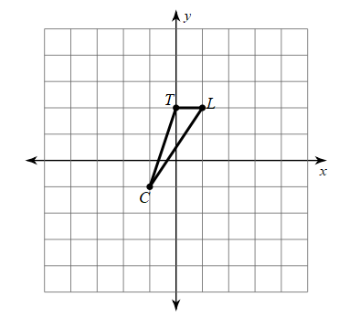C(-1, -1) → C’(_________)

1. Determine whether the dilation from Figure A to Figure B is a reduction or an enlargement. Then find its scale factor and simplify if possible.

Reduction or enlargement?

Scale Factor = __________

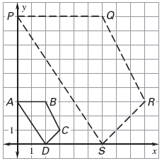

**A**

**B**

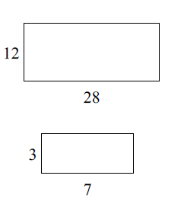3. Find the scale factor from the smaller figure to the larger figure.

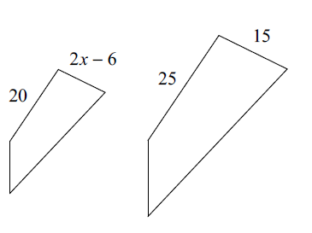4. The following polygons are similar. Solve for x.

Determine if the triangles are similar. If so, prove and write a similarity statement.

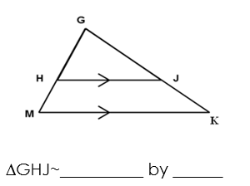5.

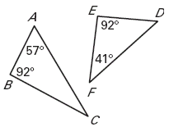6.

 ABC~__________ by ______

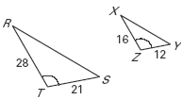7.

 RST~__________ by ______

1. A boy who is 5 ft. tall cast a shadow that is 12 ft long. At the same time, a building nearby cast a shadow that is 72 ft long. How tall is the building? Draw a picture!

Determine which of the triangles (Δ DEF or ΔGHJ) is similar to ΔABC:

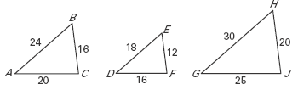

1. Complete the Similarity Statement to ΔABC ~ Δ ____________
2. Find the Scale Factor = __________

Use co-function identities to find the following:

11. 

12. 

13. 

14. Find the length of EF in DEF where ∠E = 90° and ****.

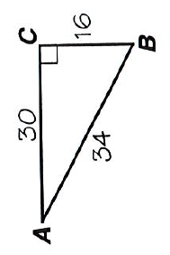

Find the following trig ratios (be sure to simplify):

15. Sin A =

16.Cos A =

17. Tan A =

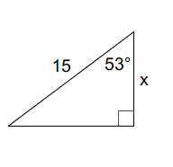Find the missing sides of the triangle.

18.

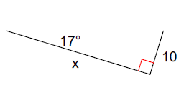19.