Name: ___________________________________________ Date: ____________________________

**EOC MULTIPLE CHOICE PRACTICE**

1. If triangle ABC is rotated 180 degrees, what are the coordinates of A’?

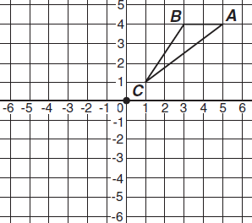

1. (-5, -4) b) (-5, 4)

c) (-4, 5) d) (-4, -5)

1. What are the coordinates of R’ after triangle RST is rotated 90 degrees clockwise?



1. (-3, -4) b) (-4, -3)

c) (3, 4) d) (4, 3)

1. Triangle RST is reflected across the y-axis and then, translated 1 unit up to create triangle R’S’T. What are the coordinates of S’?



1. (-5, -2) b) (-5, 0)

c) (-4, -1) d) (-4, 0)

1. Which statement describes the transformation that would map triangle M to triangle N on this grid?



1. (x, y) 🡪 (-x + 5, -y) b) (x, y) 🡪 (-x + 5, y)

c) (x, y) 🡪 (x + 5, -y) d) (x, y) 🡪 (x + 5, y)

1. Which expression describes the translation of a point from (-3, 4) to (4, -1)?
2. 7 units left, 5 units up b) 7 units right, 5 units up

c) 7 units left, 5 units down d) 7 units right, 5 units down

1. A regular pentagon is centered about the origin and has a vertex at (0, 4). Which transformation maps the pentagon to itself?
2. reflection across line m
3. reflection about the x-axis
4. a clockwise rotation 100° about the origin
5. a clockwise rotation 144° about the origin
6. Given: TRAP is an isosceles trapezoid with diagonals and . Which of the following must be true?

a)  b)  c)  d) bisects 

1. What values of a and b make quadrilateral MNOP a parallelogram?

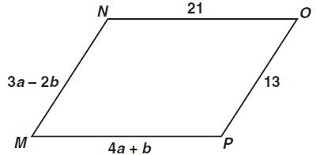

a) a = 1, b = 5 b) a = 5, b = 1 c) a = 11/7, b = 34/7 d) a = 34/7, b = 11/7

1. Quadrilateral ABCD is a parallelogram. If adjacent angles are congruent, which statement must be true?

a) ABCD is a square b) ABCD is a rhombus c) ABCD is a rectangle d) ABCD is isosceles

1. If ABCD is a parallelogram, what is the length of segment BD?

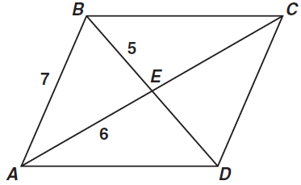

1. 10 b) 11 c) 12 d) 14
2. What is the area, in square centimeters, of rhombus RSTV if RT = 16 cm and SV = 12 cm?

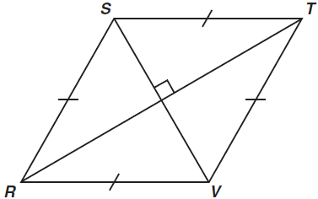

a) 40 cm.2 b) 48 cm.2 c) 96 cm.2 d) 192 cm.2

1. In the figure below, . What is the value of x?

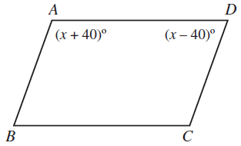

a) 40 b) 50 c) 80 d) 90