Name_________________________________________________________ Date_____________________________

**Day 1 – Triangle Base Angles and Exterior Angles**

**Find the value of “x”.**

1. 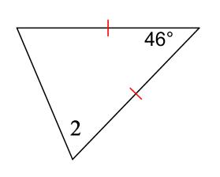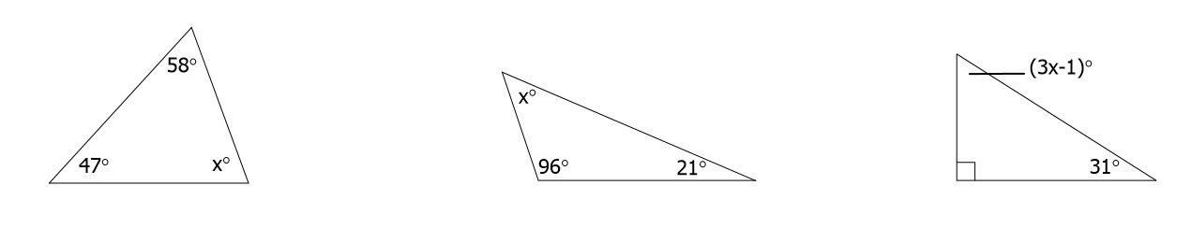x = ____________ 2) m2 = 5x+ 7 x =_________ 3) x = ____________

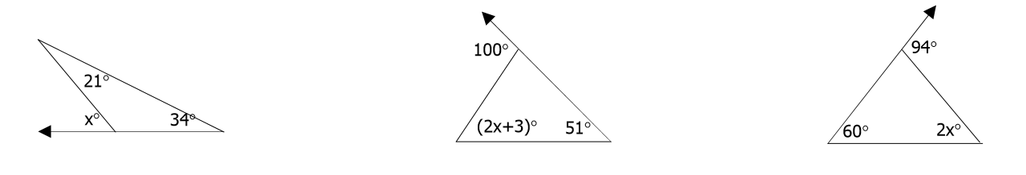  
4) x = ____________ 5) x = ____________ 6) x = ____________

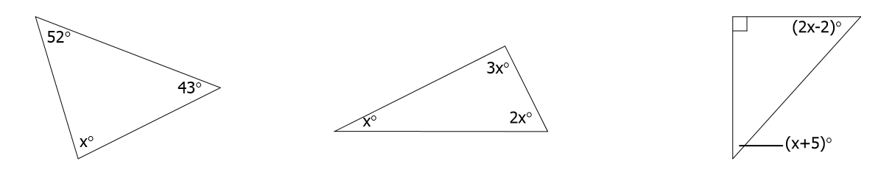7) x = ____________ 8) x = ____________ 9) x = ____________

10) m2 = 3x+ 17 x =_________ 11) x = ____________ 12) x = ____________

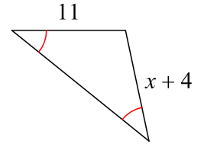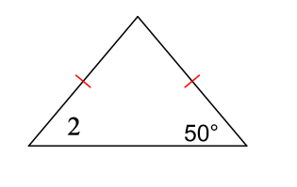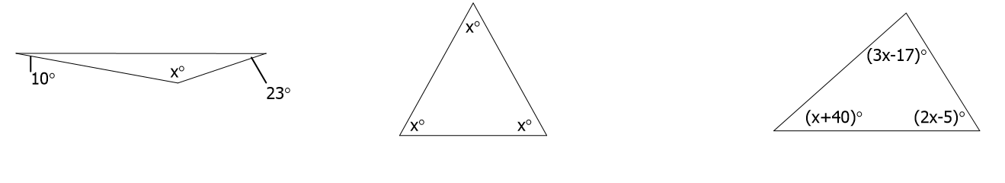

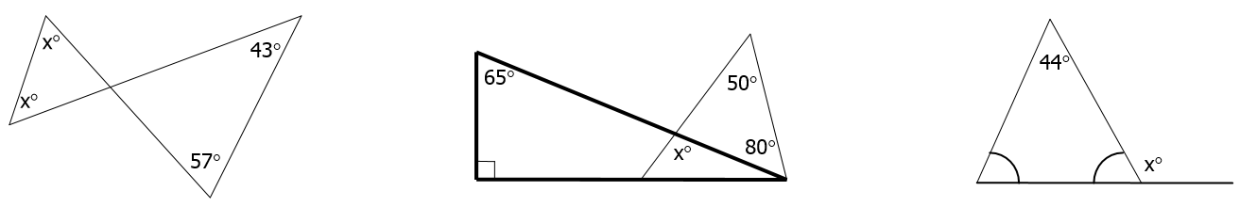13) x = ____________ 14) x = ____________ 15) x = ____________

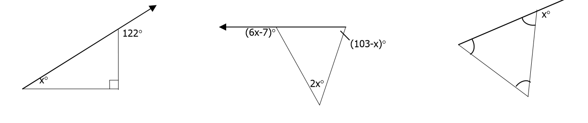16) x = ____________ 17) x = ____________ 18) x = ____________

19) x = ____________ 20) x = ____________

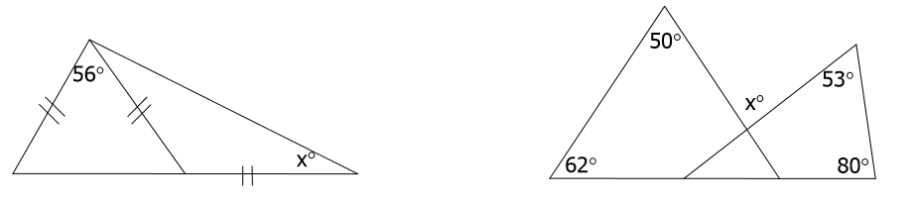

**Find the measure of each angle.**

21) 1 22) 2 23) 3

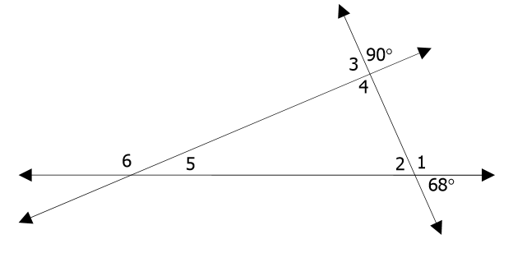 24) 4 25) 5 26) 6