Name: ______________________________________________ Date: ___________________________

**Day 7 – Triangle Proofs**

* Two-column geometric proofs are essentially just tables with __________________ on the left and a ____________________ on the right.
* The statements we make are going to be the _____________ we take toward solving our problem.
* Reasons can consist of information given within the problem itself, definitions, postulates or theorems.

|  |  |  |
| --- | --- | --- |
| **If…** | | **Then the reason is…** |
| an angle or side is ALREADY marked on the picture,  or if it is given in the directions, | |  |
| the shapes share a side |  |  |
| parallel lines create  **alternate interior angles** |  |  |
| you see **vertical angles** |  |  |
| one of the points is a **midpoint** of a line segment |  |  |
| A line segment **bisects** **a side** |  |  |
| A line segment **bisects an angle** |  |  |
| the statement states that the triangles are congruent, | |  |
| the triangles have already been proven to be congruent, and now we are trying to prove a side or angle is congruent, | |  |

**Don’t forget to ALWAYS mark your pictures!**

**Complete the following proofs:**

Practice #1:

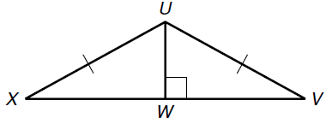Given: are right triangles, 

Prove: 

|  |  |
| --- | --- |
| **Statements** | **Reasons** |
| 1)and are rt. triangles |  |
| 2) |  |
| 3) |  |
| 4) |  |
| 5) |  |

Practice #2:

Given: Y is the midpoint of , and .

Prove: 

|  |  |
| --- | --- |
| **Statements** | **Reasons** |
| 1) |  |
| 2) |  |
| 3) Y is the midpoint of |  |
| 4) |  |
| 5) |  |

Practice #3:

Given: is isosceles with legs and . Q is the midpoint of 

Prove: 

|  |  |
| --- | --- |
| **Statements** | **Reasons** |
| 1) |  |
| 2) |  |
| 3) |  |
| 4) |  |
| 5) |  |
| 6) |  |

Practice #4:

Given: 

Prove: 

|  |  |
| --- | --- |
| **Statements** | **Reasons** |
| 1) |  |
| 2) |  |
| 3) |  |
| 4) |  |

Practice #5:

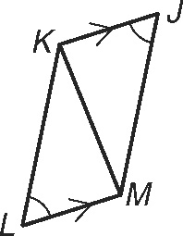Given: 

Prove: 

|  |  |
| --- | --- |
| **Statements** | **Reasons** |
| 1) |  |
| 2) |  |
| 3) |  |
| 4) |  |
| 5) |  |