Name ________________________________________________________________________ Date _______________________

**Day 8 – More Proofs**

Use the information given in the diagram and the Reasons Bank to give a reason why

each statement is true. Some reasons may be used more than once.

**Given:** *****L*  *****Q, N is the midpoint of LQ*

**Prove: ***LNM*  *****QNP*

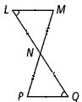

**Statements Reasons**

**1) ***L*  *****Q*  **1)**

**2)** N is the midpoint of LQ  **2)**

**3) ****3)**

**4) ***LNM******QNP* **4)**

**5) ***LNM*  *****QNP* **5)**

**Reasons Bank:**

* Definition of a midpoint
* Vertical angles are congruent
* Reflexive Property
* All right angles are congruent
* Given
* ASA SAS SSS AAS

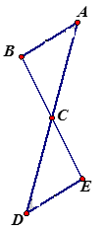

**2. Given:** and ** bisect each other.

|  |  |
| --- | --- |
| **Statements** | **Reasons** |
| 1) and bisect each other. | 1) |
| 2) ≅ *,* ≅ | 2) _________________________________________________q |
| 3) ∠*ACB* ≅ ∠*DCE* | 3) |
| 4) Δ*ACB* ≅ Δ*DCE* | 4) |

**Prove**: ∆ACB ≅ ∆DCE

**Reasons Bank:**

* Definition of a midpoint
* Vertical angles are congruent
* Reflexive Property
* All right angles are congruent
* Definition of a bisector
* Given
* ASA SAS SSS AAS

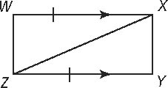

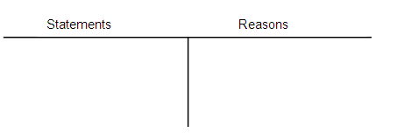

**3.** Given: 

Prove: Δ*WXZ* ≅ Δ*YZX*

$\overline{WX} || \overline{YZ}, \overline{WX}≅\overline{YZ}$

$∠WXZ≅∠YZX$

$\overline{XZ}≅\overline{XZ}$

$∆WXZ≅∆YZX$

**Reasons Bank:**

* Definition of a midpoint
* Vertical angles are congruent
* Reflexive Property
* All right angles are congruent
* Definition of a bisector
* If two parallel lines are cut by a transversal, then the corresponding angles are congruent
* If two parallel lines are cut by a transversal, then the alternate interior angles are congruent
* ASA SAS SSS AAS

**Write a two-column proof.**

**4.** Given:**

Prove:Δ*ABC* ≅ Δ*EDC*

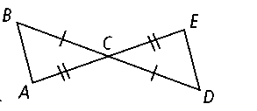 

Statements Reasons

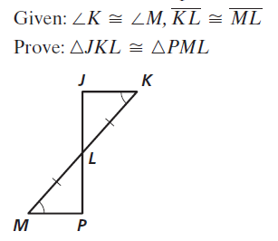**5.** Given: ∠K ≅ ∠L, KL ≅ LM

Prove: ∆JKL ≅ ∆PML

Statements Reasons