Name _________________________________________________ Date _______________________

**Day 8 – More Proofs**

**Fill in the missing statements or reasons from the bank**:

**Problem 1:**

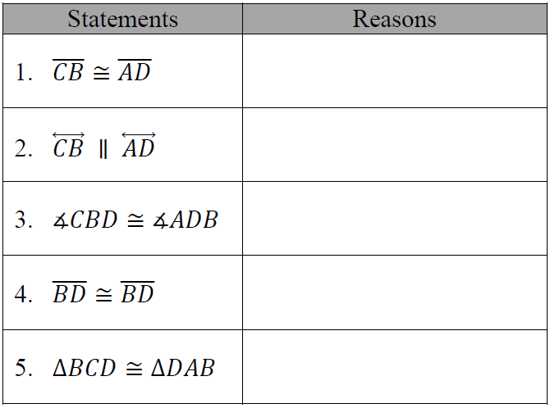

Given: and 

*Prove*: ΔBCD  ΔDAB



Corresponding angles are congruent SAS AAS

Given SSS ASA

Transitive Property of Congruence Reflexive Property of Congruence

Alternate interior angles are congruent Definition of an Angle Bisector

Right Angle Congruence Theorem Definition of a Midpoint

**Problem 2:**

Given: ΔWOK is isosceles;

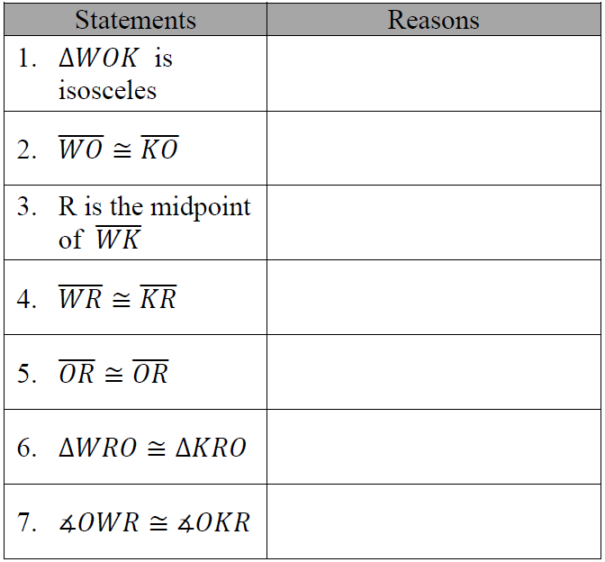

Point R is the midpoint of 

*Prove*: <OWR  <OKR



Definition of a Midpoint SAS AAS HL

Given SSS ASA

Transitive Property of Congruence Reflexive Property of Congruence

CPCTC Definition of an Isosceles Triangle

Right Angle Congruence Theorem Congruent Base Angles Theorem

Definition of an Angle Bisector

**Problem 3:**

Given:  and 

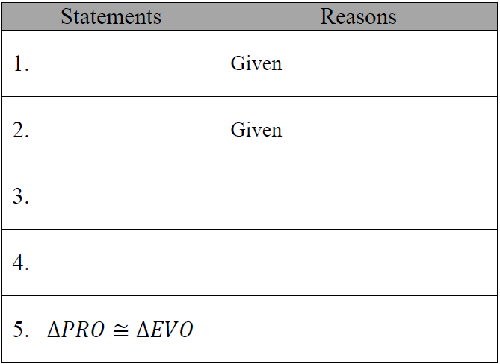

*Prove*: ΔPRO  ΔEVO



Alternate Interior Angles are Congruent SAS AAS

Definition of a Midpoint SSS ASA

Transitive Property of Congruence Reflexive Property of Congruence

Vertical Angles are Congruent Corresponding Angles are Congruent

Definition of an Angle Bisector

  

  

**Fill in the missing statements or reasons:**

**Problem 4:**

Given: Point I is the midpoint of 

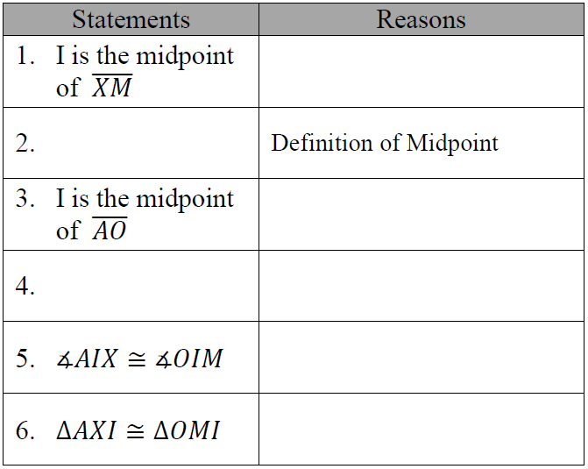

Point I is the midpoint of 

*Prove*: ΔAXI  ΔOMI

