Name _______________________________________________________________ Date ________________________________

**Day 1 – Circle Vocabulary and Central Angles**

|  |  |  |
| --- | --- | --- |
| **Circle** | set of all points equidistant  from a given point called  the center of the circle |  |
| **Chord** | a segment whose endpoints  are on the circle |  |
| **Diameter** | distance across the circle  through its ______________ |  |
| **Radius** | distance from the center  to point on circle |  |
| **Secant** | a line that intersects the  circle at exactly __________ points |  |
| **Tangent** | a __________ that intersects the  circle exactly ONE time |  |
| **Point of Tangency** | where the tangent line  intersects the circle |  |

Circles have _______ degrees. Semicircles have _______ degrees.

**REMEMBER:** Vertical Angles are ______________ and Linear Pairs are ____________________________

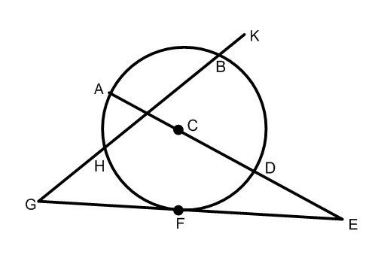**Practice:** Tell whether the line or segment is best described as a chord, a secant, a tangent, a diameter, or a radius—be specific!

a.  b. 

c.  d. 

e.  g. 

**Arcs & Central Angles**

An **arc** is an unbroken part of a circle consisting of two points called the endpoints and all the points on the circle between them.

|  |  |  |  |
| --- | --- | --- | --- |
| **Arc or Angle** | **Definition** | **Measure** | **Picture** |
| Minor Arc | An arc whose points are on or in the interior of a central angle. Minor arcs are less than 180 and only use two letters to name them. | The measure of a minor arc is equal to the measure of the central angle. |  |
| Major Arc | An arc whose endpoints are on or in the exterior of a central angle. Major arcs are between 180 and 360. Three letters are used to name a major arc. | The measure of a major arc is equal to 360 minus the measure of its central angle or minor arc. |  |
| Semicircle | An arc whose endpoints lie on a diameter. Semicircles are named using three letters. | The measure of a semicircle is 180. |  |
| Central Angle | An angle whose vertex is the center of the circle. | The measure of a central angle is equal to the measure of its minor arc. |  |
| **Name** | **Theorem** | **Hypothesis** | **Conclusion** |
| Arc Addition Postulate | The measure of an arc formed by two adjacent arcs is the sum of the measures of the two arcs. |  |  |

**Practice**

**Example:** Identify the following arcs are minor, major, or semicircle.

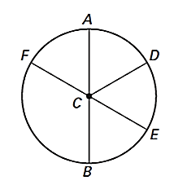

**Example:** Find the measure of the following:

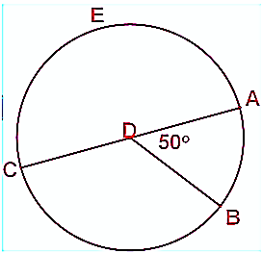****

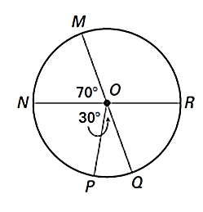**Example:** Find the measure of the following:



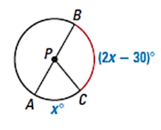**Example:** Find the value of x. Then find the measure of arc BC.