Name ____________________________________________________________________ Date ___________________________Day 3 – Tangent Properties
Last unit, you learned that tangent lines intersect a circle in exactly one place. This leads to several theorems about tangent lines.

Tangent Circles are two coplanar circles that intersect at exactly one point. They may intersect internally or externally.
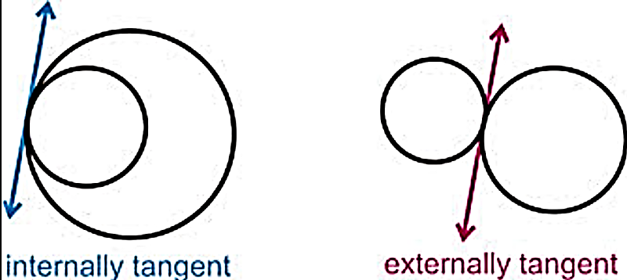

Common Tangent Lines are lines that are tangent to two circles.
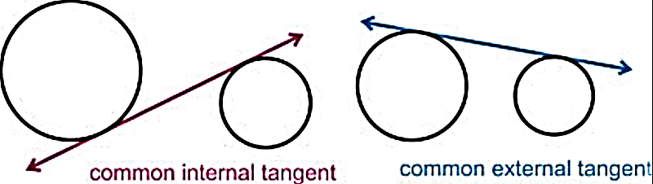

Example: Draw any common tangent lines.
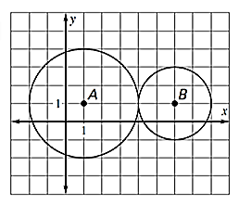

Other Points of Intersection:
Circles may also intersect at two or no points.
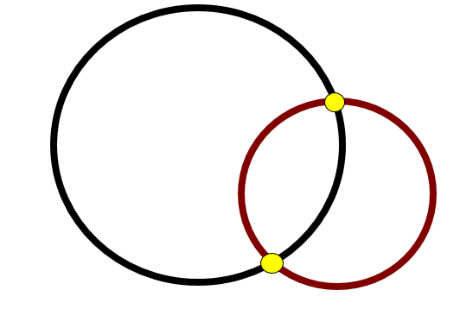

No Points of Intersection:
These circles are called Concentric Circles. They have no points of intersection but they have the same center and different radii.

No Points of Intersection:
No points of intersection with different centers.
Two Points of Intersection

Tangent Theorems

Name | Theorem | Hypothesis | Conclusion
Perpendicular Tangent Theorem | If a line is tangent to a circle, then it is perpendicular to the radius drawn to the point of tangency. | 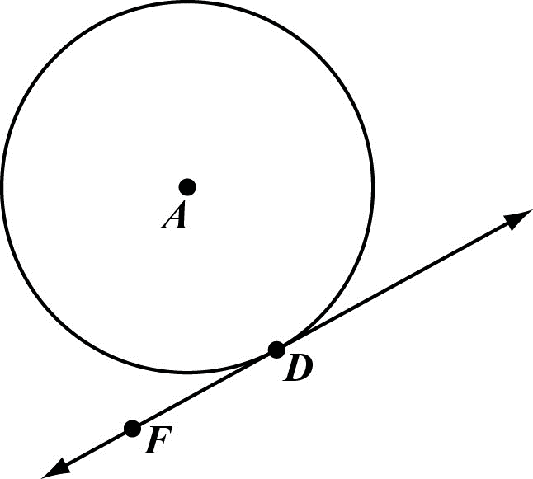
Converse of Perpendicular Tangent Theorem | If a line is perpendicular to a radius of a circle at a point on the circle, then the line is tangent to the circle. | 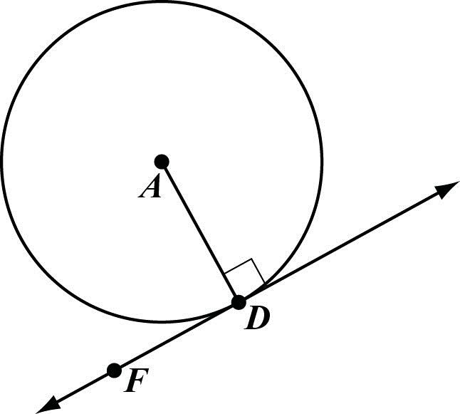
Tangent Segments Theorem | If two segments are tangent to a circle from the same external point, then the segments are congruent. | 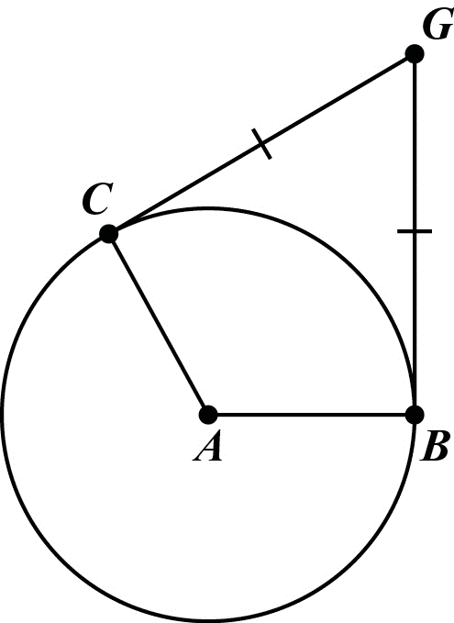

Example: Is AB tangent to Circle C? Example: Find the length of RQ. Example: Find x.
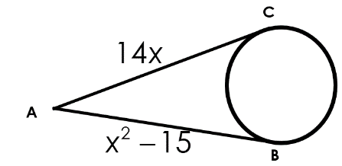
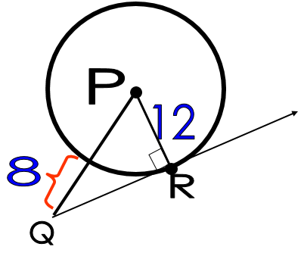
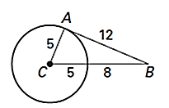

Example: Find perimeter of triangle ABC. Example: Find DF if you know that DF and DE are tangent to.
