Name: _____________________________________________________ DUE DATE: THURSDAY APRIL 18, 2019

1. A student constructs the image of line segment AB under a dilation with center O, not on the segment, with a scale factor of 3. Which describes the image of the line segment?
   1. The image of line segment AB is a line segment parallel to AB
   2. The image of line segment AB is a line segment perpendicular to AB
   3. The image of line segment AB is a line segment passing through point O that intersects AB
   4. The image of line segment AB is a line segment passing through point O that leaves AB unchanged
2. AB with length 2.4 cm is dilated with a scale factor of 3. What is the new length of AB?
   1. 0.8 cm
   2. 2.4 cm
   3. 5.4 cm
   4. 7.2 cm
3. A right triangle with hypotenuse 5 units and one leg 4 units is dilated with a scale factor of 2. What is the length of the smallest side of the new triangle?
   1. 3 units
   2. 6 units
   3. 8 units
   4. 10 units

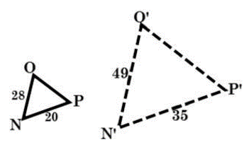

1. What is the scale factor of the dilation?
   1. 7/4
   2. 4/7
   3. 7/5
   4. 5/7
2. Δ *NOP* has side lengths of 5 cm, 7 cm, and 9 cm. If Δ *NOP* ~ Δ *RST*, which could be side lengths of Δ *RST*?
   1. 1 cm, 3, cm, 5 cm
   2. 6 cm, 8.4 cm, 13.5 cm
   3. 7.5 cm, 10.5, 13.5 cm
   4. 15 cm, 17 cm, 19 cm
3. 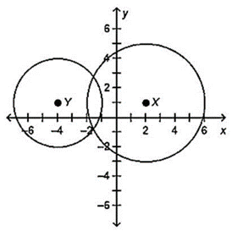What scale factor could be used to dilate circle X

to be congruent to circle Y?

* 1. 4/3
  2. 3/4
  3. 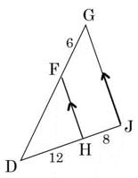3/5
  4. 2/1

1. In the triangle to the right, what is the length of segment *DF*?
   1. 9
   2. 10
   3. 12
   4. 20
2. 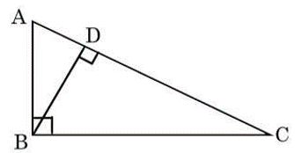Select the **1** triangle that correctly completes

the similarity statement? ΔABC ~ Δ ____

1. ΔABD
2. ΔADB
3. ΔBCD
4. ΔBCA
5. 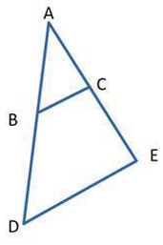Segment BC is a midsegment and triangle ADE. Find the

length of BC if BC=2x+14 and DE = 6x - 12.

* 1. 7
  2. 20
  3. 28
  4. 54

1. 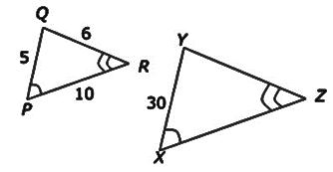Given: Δ*PQR* ~ Δ*XYZ*.

What is the perimeter of Δ*XYZ*?

* 1. 21
  2. 63
  3. 105
  4. 126

1. 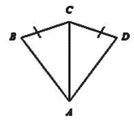What additional information do you need to prove the two

triangles are congruent by the SAS Postulate?

* 1. 
  2. 
  3. 
  4. 

1. 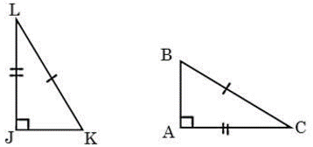Which statement is **TRUE**?
   1. Δ*ABC $≅$* Δ*JLK* by HL
   2. Δ*ABC $≅$* Δ*JKL* by HL
   3. Δ*ABC $≅$* Δ*JLK* by SAS
   4. Δ*ABC $≅$* Δ*JKL by SSS*
2. Heather is 1.6 meters tall and casts a shadow of 3.5 meters.

A barn nearby casts a shadow of 17.5 meters. What is the height of the barn?

* 1. 5 m
  2. 8 m
  3. 14 m
  4. 38 m

1. Given: A (3,1), B (4,5), C (2,3), D (-1, -3), E (-5, -4), F (-3, -2)

Which statement proves ΔABC maps onto ΔDEF?

* 1. Rotation:  **(x,y) → (y, -x),** followed by a Reflection: **(x, y) → (x, -y).**
  2. Reflection:  **(x,y) → (-x, y),** followed by a Rotation: **(x, y) → (y, -x).**
  3. Translation:  **(x,y) → (x-4, y),** followed by a Translation: **(x, y) → (x, y-6).**
  4. Rotation:  **(x,y) → (-y, x),** followed by a Reflection: **(x, y) → (x, -y).**

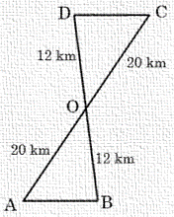

1. A pilot uses triangles to find the angle of elevation,  from

the ground to her plane. If , how can she find ?

* 1.  by SAS &  by CPCTC,

so  by substitution.

* 1.  by CPCTC &by SAS,

so by substitution.

* 1.  by ASA &  by CPCTC,

so by substitution.

* 1.  by CPCTC &  by ASA,

so by substitution.

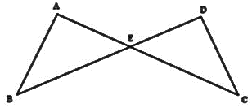

1. Point *E* is the midpoint of line segments *AC* and *BD*.

Which is the **TRUE** statement?

1.  by ASA
2. by AAS
3. by SAS
4. by SSS

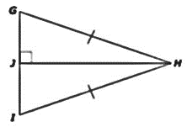

1. Use the figure to answer the question.

Which is the **TRUE** statement?

1.  by SAS
2.  by HL
3.  by SSS
4.  by HL
5. Two lines intersect to form two pairs of vertical angles:  are vertical angles.  are vertical angles.

What are the values of x and y and the measure of  ?

* 1. 
  2. 
  3. 
  4. 

1. For two parallel lines and a transversal, ∠1 and ∠2 are same-side interior angles, ∠2 and ∠3 are vertical angles, ∠3 and ∠4 are alternate exterior angles. Which classification best describes the relationship between ∠2 and ∠4?
   1. Adjacent
   2. Corresponding
   3. 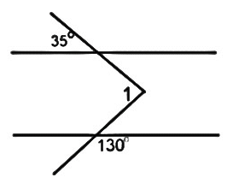Alternate Interior
   4. Vertical
2. What is *m*1? *(Hint: Draw a line parallel to the given parallel lines.)*
   1. 
   2. 
   3. 
   4. 

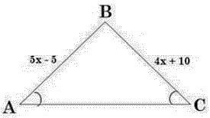

1. What is the length of AB?
   1. 5
   2. 15
   3. 30
   4. 70

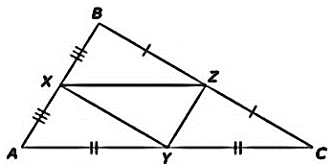

1. Given: *BC* = 3x - 1 and *XY* = 2x - 3.

What is the length of *XY*?

* 1. 5 units
  2. 7 units
  3. 14 units
  4. 28 units

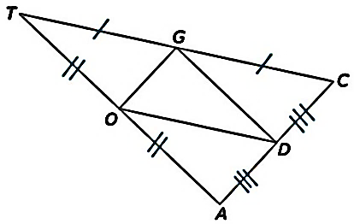

1. If *AD=5*, *AT* = 18, and *CT* = 22, find the perimeter of Δ*DOG*?
   1. 25
   2. 33
   3. 40
   4. 50

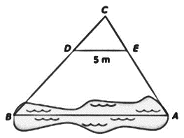

1. A surveyor locates points *A*, *B*, *C*, *D*, and *E* of a pond. Triangle CDE is similar

to Triangle CBA. *CD*=4 and *CB*=12. Using the lengths measured, what is

the length of *AB* to the nearest meter?

* 1. 10 meters
  2. 12 meters
  3. 15 meters
  4. 18 meters

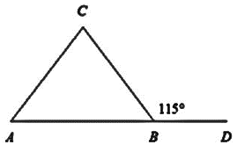

1. Two Galaxy systems, Tauri and M77, represented by points A and B,

are equidistant from Earth, represented by point C. What is mA?

* 1. 65°
  2. 115°
  3. 50°
  4. 77°

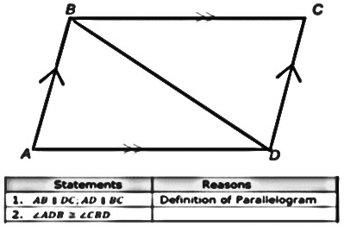

1. Given: ABCD is a parallelogram. Prove: ∠*A* ≅ ∠*C*; ∠*B* ≅∠*D*

What is the reason for Step 2 in this incomplete proof?

* 1. Definition of parallelogram
  2. When parallel lines are cut by a transversal,

alternate interior angles are congruent.

* 1. 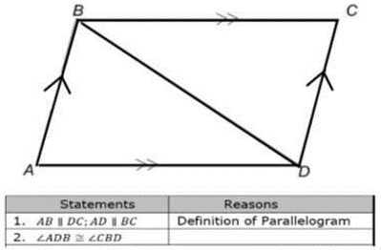When parallel lines are cut by a transversal,

corresponding angles are congruent.

* 1. Corresponding parts of congruent triangles

are congruent.

1. Given quadrilateral ABCD with AB ≅ CD; BC ≅ DA, and AC ≅ BD. Which of the following is correct concerning quadrilateral ABCD?
   1. Opposite sides are congruent, so ABCD is a parallelogram. Diagonals are congruent, so ABCD is a rectangle. Two consecutive sides are not necessarily congruent, so ABCD is NOT a square.
   2. Opposite sides are congruent, so ABCD is a rhombus. Diagonals are congruent, so ABCD is a rectangle. A quadrilateral that is a rhombus and a rectangle is a square, so ABCD is a square.
   3. Opposite sides are congruent, so ABCD is a parallelogram. Diagonals are congruent, so ABCD is a rhombus. One angle is not a right angle, so ABCD is NOT a square.
   4. The conclusion is valid without any more information needed. ABCD is a square.

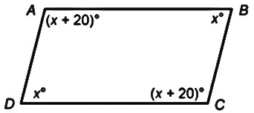

1. In quadrilateral ABCD, AB ≅ DC and AD ≅ BC. Find the m∠D.
2. 180°
3. 80°
4. 40°
5. 100°

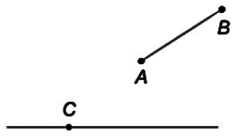

1. *Thinking Constructions:* What is the first step to copy *AB* onto the line?
   1. Use a straightedge to draw *AB* so it intersects the other line.
   2. Open a compass to the distance of *AB*.
   3. Use a ruler to measure *AB*.
   4. Use a straightedge to draw *AB*.
2. Which step should be first to construct a line perpendicular to *HJ* at point *J*?
   1. Place the compass on point *H,* set its width to less than *HJ*, draw two arcs on both sides of *H*.
   2. Place the compass on point *J,* set its width to less than *HJ*, draw two arcs on both sides of *J*.
   3. Place the compass on point *J,* set its width to less than *HI*, draw a circle that will intersect the segment in two places.
   4. Place the compass on point *J,* set its width to more than *JI*,

draw a circle around the segment *HI.*

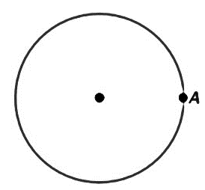

1. What is the first step when inscribing a regular hexagon in the circle?
   1. Set the compass to any distance. Then place the point of

the compass at *A* and draw an arc that passes through

any point on the circle.

* 1. Place the point of the compass at any point on the circle &

draw an arc that passes through point *A*.

* 1. Open the compass to the radius of the circle.
  2. Draw the diameter of the circle.

1. Given Δ*PQR $≅$* Δ*XYZ,* which statement is **NOT** true?
   1. PR $≅$ XZ
   2. YZ $≅$ QR
   3. RQ $≅$ ZX
   4. ZY $≅$ RQ
2. Triangle BCD has been dilated to create triangle B'C'D'.

(NOTE: Your teacher will score your response to this question using a 2-point rubric.)

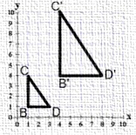

* **Part A:**  What is the scale factor that created Δ*B’C’D’?*

* **Part B:**  What is the similarity ratio of the areas from the

pre – image to the image?