Name: ____________________________________________________ Date: _____________________________



1. What is the correct ratio for tan B?
   1. 
   2. 
   3. 
   4. 
2.  Which of the following must be **TRUE**?
   1. tan G = tan L
   2. tan G = tan M
   3. sin H = sin L
   4. sin H = tan M



1. What is the value of sin X?
   1. 
   2. 
   3. 
   4. 
2. Which of the statements are **TRUE**?

I. You can solve a right triangle if you are given the lengths of any two sides.

II. You can solve a right triangle if you are given the measures of two acute angles.

III. You can solve a right triangle if you are given the length of 1 side & the measure of 1 acute angle.

* 1. I only
  2. II only
  3. II and III
  4. I and III

1. In right  Which statement about must be **TRUE**?
   1. 
   2. 
   3. 
   4. 
2. Which of the following is equal to 
   1. 
   2. 
   3. 
   4. 
3. In right are complementary angles. If  what is the value for 
   1. 
   2. 
   3. 
   4. 
4. In right are the acute angles. If  what is 
   1. 
   2. 
   3. 
   4. 
5. 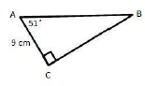What is the perimeter of the right triangle? Round to the nearest tenth of a centimeter.
6. 
7. 
8. 
9. 

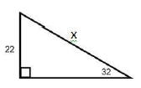

1. What is the length of the hypotenuse? Round to the nearest tenth.
2. 11.7
3. 25.9
4. 35.2
5. 41.5
6. 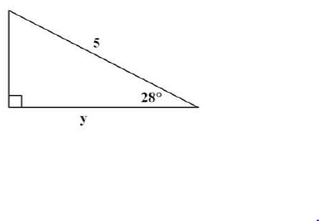Which of the following shows the correct way to solve for y.
7. 
8. 
9. 
10. 

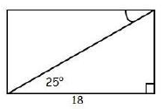

1. What is the length of the diagonal of the rectangle?

Round to two decimal places.

1. 7.61
2. 16.31
3. 19.86
4. 38.60

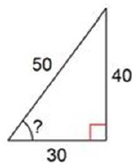

1. What is the missing angle in the triangle?
2. 
3. 
4. 
5. 

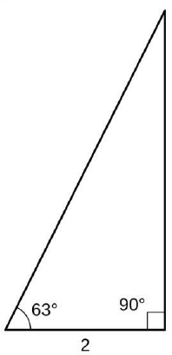

1. Shane is cutting a piece of tile as shown in the diagram.

Which equation can be used to find x, the length of the

longest side of the piece of tile?

1. 
2. 
3. 
4. 
5. The perimeter of an equilateral triangle is 36 meters. What is the height of the triangle?
6. 
7. 
8. 
9. 
10. What is the length of the diagonal of a square with side lengths ?
11. 
12. 
13. 
14. 

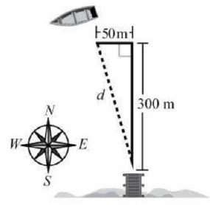

1. A boat travels 300 meters (m) north from a dock in an ocean.

Because of the current, the boat is also carried 50 meters west

as shown. What is the distance, d, from the boat to the dock,

rounded to the nearest meter?

1. 250 m
2. 296 m
3. 304 m
4. 350 m
5. A kite is flying 70 feet above the ground and is attached to a string tied to a stake on the ground. The angle of elevation formed by the string and the ground is 40°. What is the length of the string? Round to the nearest foot.
6. 45 feet
7. 83 feet
8. 91 feet
9. 109 feet
10. Ranger Chris spots a fire at an angle of depression of 20° from his 70 feet tall tower. How far is the fire from the base of the tower?
11. 23.94 feet
12. 25.48 feet
13. 192.32 feet
14. 204.67 feet
15. Thomas stands 65 yards from the base of a lighthouse. The height of the lighthouse is 75 yards. What is the angle of depression from the top of the lighthouse to Thomas?
16. 
17. 
18. 
19. 
20. The legs of a right triangle measure 11.4 meters and 15.1 meters. To the nearest tenth, what is the measure of the smallest angle in the triangle?
    1. 
    2. 
    3. 
    4. 
21. The angle of elevation to the top of a tree for a person whose eye level is 5 feet above the ground is 29°. The person is standing approximately 162 feet from the base of the tree. What is the height of the tree to the nearest foot? 
    1. 79 feet
    2. 84 feet
    3. 90 feet
    4. 95 feet
22. A ramp leading to a building is 30 feet long and stands 6 feet high.

(NOTE: Your teacher will score your response to this question using a 4-point rubric.)

* **Part A** Draw a picture to illustrate the problem.
* **Part B** Find the angle of elevation of the ramp that was built.

Round answer to the nearest hundredth, if necessary.

* **Part C** The building code for the city states that angle of a ramp cannot exceed 10 degrees. Does the ramp meet code regulations? Explain why or why not.

____________________________________________________________________________________________________________________________________________________________________________________________________________________________________________________________________________________________________________________________________________________

* **Part D** If the ramp does NOT fit regulations, how can the builder change the ramp to make it comply with building code regulations? Be specific

_______________________________________________________________________________________________________________________________________________________________________________________________________________________________________________________________

_____________________________________________________________________________________