Name: _________________________________________________________ DUE DATE: TUESDAY APRIL 9, 2019

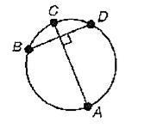

1. Given: Segment AC bisects segment BD. Which statement is **TRUE**?
   1. 
   2.  is a diameter.
   3.  is a major arc.
   4.  is a minor arc.
2. 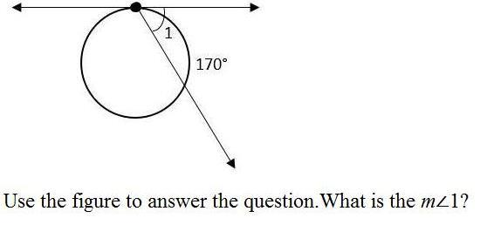Use the figure to answer the question. What is the ?
   1. 170°
   2. 190°
   3. 85°
   4. 95°

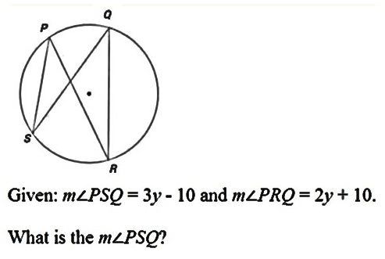

1. Given: . What is the ?
   1. 25°
   2. 50°
   3. 30°
   4. 20°

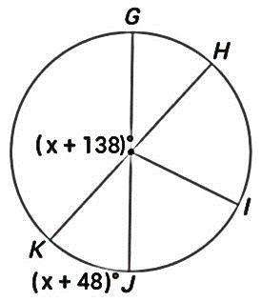

1. Use the figure to answer the question. What is the ?
   1. 135º
   2. 115º
   3. 143º
   4. 149º
2. Point *B* is on the tangent line and is 18 feet from the center of the circular water storage tank. Point A is the point of tangency. If AB = 16, what is the radius of the tank?

(Hint: Draw a diagram)

* 1. 18.6 ft
  2. 16.5 ft
  3. 8.2 ft
  4. 24.1 ft

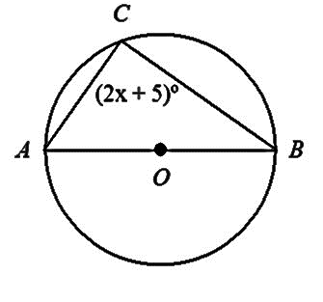

1. Use the figure to answer the question. What is the value of x?
   1. 42.5 units
   2. 90 units
   3. 87.5 units
   4. 27.5 units
2. 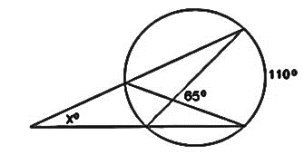Use the figure to answer the question. What is the value of x?
   1. 20º
   2. 45º
   3. 55º
   4. 90º

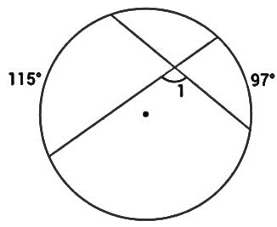

1. Use the figure to answer the question. What is the value of x?
   1. 74º
   2. 18º
   3. 106º
   4. 164º

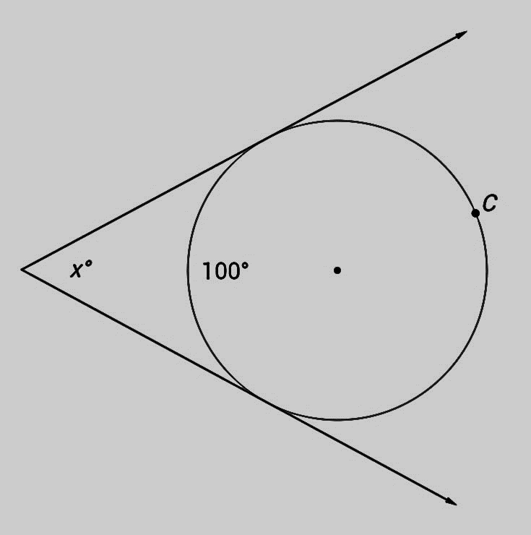

1. Use the figure to answer the question. What is the value of x?
   1. 50º
   2. 80º
   3. 130º
   4. 260º

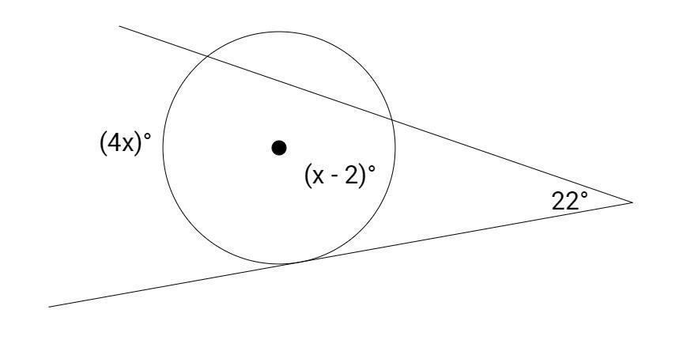

1. Use the figure to answer the question. What is the value of x?
   1. 14º
   2. 15.7º
   3. 16.7º
   4. 22º

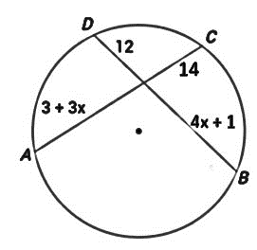

1. Use the figure to answer the question. What is the length of CA?
   1. 5
   2. 18
   3. 21
   4. 32

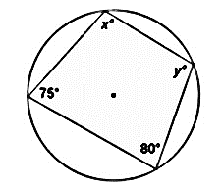

1. Use the figure to answer the question. What are the values of x and y?
   1. x = 80°, y = 75°
   2. *x* = 105°, *y* = 100°
   3. *x* = 75°, *y* = 80°
   4. x = 100°, y = 105°

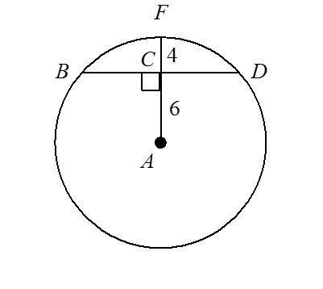

1. Use the figure to answer the question. What is the length of BD?
   1. 16
   2. 8
   3. 5
   4. 10

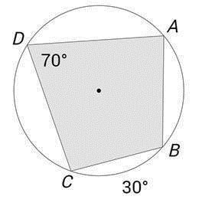

1. Given: . What is 
   1. 90º
   2. 100º
   3. 110º
   4. 150º
2. 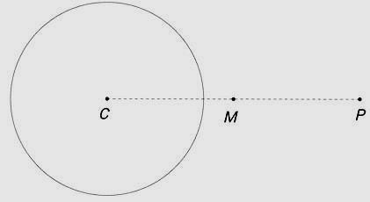Manuela is constructing a tangent line from

point *P* to circle *C*. She has already drawn *CP*

and found the midpoint *M*. Where should

Manuela place the point of her compass to

continue the construction?

* 1. 4
  2. Point M
  3. Point P
  4. Any point X on circle C

1. What is the constant of proportionality for the relationship between the length of the arc intercepted by an 80° angle and the radius of the circle?
   1. 
   2. 
   3. 
   4. 
2. 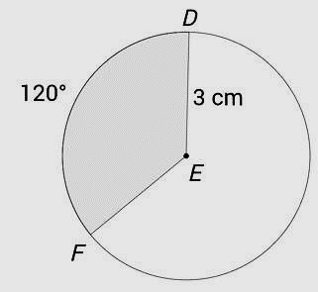Use the figure to answer the question. What is the length of in terms of pi?
   1. 
   2. 
   3. 
   4. 
3. Marco orders a large pizza, with a diameter of 14 inches. It is cut into 8 congruent pieces. What is the area of one piece?
   1. 
   2. 
   3. 
   4. 
4. Jenny’s birthday cake is circular and has a 30 cm radius. Her slice creates an arc with a central angle of 120°. What is the area of the top of Jenny’s slice of cake? Give your answer in terms of π.
   1. 
   2. 
   3. 
   4. 

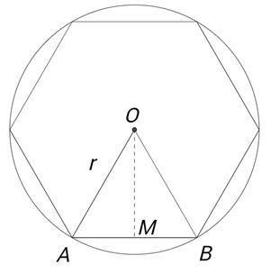

1. The figure shows a regular hexagon inscribed in a circle with

*OM* drawn from the center of the circle to the midpoint of

side *AB*. Which statement is **TRUE**?

* 1. ** is an equilateral triangle.
  2. ** is an equilateral triangle.
  3. ** is congruent to*.*
  4. ** is the radius of circle O.

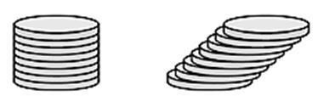

1. Jason constructed two cylinders using solid metal washers.

The cylinders have the same height, but one of the

cylinders is slanted as shown in the figure. Which

statement is true about Jason’s cylinders?

* 1. The cylinders have different volumes because they have different radii.
  2. The cylinders have different volumes because they have different surface areas.
  3. The cylinders have the same volumes because each of the washers has the same height.
  4. The cylinders have the same volumes because they have the same cross-sectional area at every plane parallel to the bases.

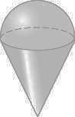

1. The radius of the hemisphere is 2.5 units and the height of the cone is 5 units.

What is the volume of the figure?

* 1. 32.72 units
  2. 98.17 units
  3. 65.45 units
  4. 52.35 units

1. The volume of the sphere is 36π cubic inches. What is the radius?
   1. 2 in
   2. 3 in
   3. 7 in
   4. 8 in

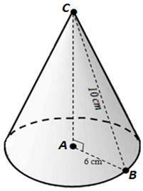

1. The cone shown has a base with radius *AB* = 6 cm.

The slant height length of *BC* = 10 cm.

What is the volume of the cone?

* 1. 
  2. 
  3. 
  4. 

1. Which figure could **NOT** represent the cross section of a cylinder?
   1. A circle
   2. A semicircle
   3. A square
   4. A rectangle
2. Which 3D figures can be generated by rotating a 2D figure around a line?
   1. Cylinder, Sphere, Cone
   2. Cone, Prism, Pyramid
   3. Pyramid, Cone, Sphere
   4. Cylinder, Cone, Pyramid

1. 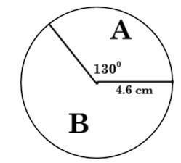NOTE: Your teacher will score your response to this problem using a 2-point rubric.

* **Part A**: Find the **area of sector B** in the given circle.
* **Part B**: Find the **length of the arc** that contains sector A.