Name: ____________________________________________________ Date: _______________________________

1. A fish tank is in the shape of a rectangular prism. The dimensions of the tank are 18 inches by 17 inches by 38 inches. If 1 liquid gallon = 231 cubic inches, what is the amount of water the tank can hold to the nearest gallon?
   1. 7 gallons
   2. 50 gallons
   3. 1,558 gallons
   4. 7,231 gallons
2. A human’s eyeball is shaped like a sphere with a diameter of 2.5 cm. A dog’s eyeball is shaped like a sphere with a diameter of 1.75 cm. About how many times greater is the volume of a human’s eyeball than the volume of a dog’s eyeball?
   1. About 1.5 times greater
   2. About 3 times greater
   3. About 8 times greater
   4. About 23 times greater
3. A cylindrical soda can is made of aluminum. It is approximately 5 inches high and the top and bottom have a radius of approximately 1.25 inches. If , what is the approximate surface area of the soda can?
   1. The approximate surface area of the soda can is 41 square inches.
   2. The approximate surface area of the soda can is 47 square inches.
   3. The approximate surface area of the soda can is 49 square inches.
   4. The approximate surface area of the soda can is 55 square inches.

1. The earth can be modeled as a sphere with diameter 12,700 km with about 30% percent potentially habitable by humans. There are approximately 7.1 billion people in the world. If the surface area of the earth is approximately 506,707,500 square km, what is the approximate population density of potentially habitable earth?
   1. About 4.6 people per sq. km
   2. About 46 people per sq. km
   3. About 460 people per sq. km
   4. About 4600 people per sq. km
2. The volume of a solid gold statue can be approximated as 1000 cm3. If the density of gold is about 20 g/cm3, what is the mass of the statue?
   1. 50 g
   2. 500 g
   3. 2,000 g
   4. 20,000 g
3. The table shows the population ad land area of four different islands.

Given the table, which island has the greatest population density?

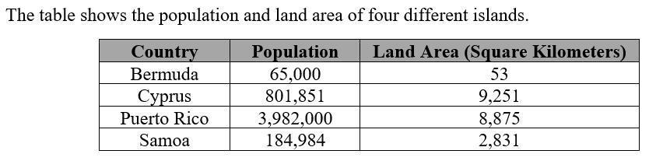

* 1. Bermuda
  2. Cyprus
  3. Puerto Rico
  4. Samoa

1. Demographers calculate the population density of a city as the number of people per square mile. In 2013, San Francisco had a population of 837,000 people living in 47 square miles. What was San Francisco’s population density in 2013?
   1. 56 people per square mile
   2. 17,809 people per square mile
   3. 837,047 people per square mile
   4. 39,339,000 people per square mile
2. You want to design a cylindrical container for oatmeal that has a volume of 90 cubic inches. You also want the height of the container to be 3.5 times the radius. To the nearest tenth, what should the radius of the container be?
   1. 2.0 in
   2. 2.9 in
   3. 3.0 in
   4. 5.1 in
3. 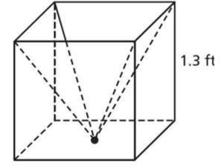A wire frame in the shape of the cube is used to support a

pyramid-shaped basket, as shown. The vertex of the pyramid

lies in the same plane as a face of the cube. To the nearest

tenth, what is the volume of the pyramid-shaped basket?

* 1. 0.7 cubic ft.
  2. 1.1 cubic ft.
  3. 1.7 cubic ft.
  4. 2.2 cubic ft.

1. A room measures 15 ft by 20 ft by 10 ft. If a basketball has a diameter of 9.6 inches, approximately how many basketballs will be needed to fill the room?
   1. Approximately 1,000
   2. Approximately 4,000
   3. Approximately 8,000
   4. Approximately 11,000
2. What is the equation of a circle with center (-3, 5) that passes through the point (1, 5)?
   1. 
   2. 
   3. 
   4. 
3. A circle has the equation . What is the length of the diameter of the circle?
   1. 7
   2. 14
   3. 49
   4. 98

1. The center of a circle with radius 3 is (-1, 2) and a point on the circle is (x, y). Using the Pythagorean theorem, which of the statements correctly shows how to derive the equation of this circle?
   1. 
   2. 
   3. 
   4. 
2. Find the center and radius of the circle with equation (x – 3)2 + (y + 2)2 = 25.
   1. center: (3, -2); radius: 25
   2. center: (-2, 3); radius: 5
   3. center: (3, -2); radius: 5
   4. center: (-3, 2); radius: 25
3. On a map of a park, statues are located at (4, -2), (-1, 3), and (-5, -5). A circular path connects the three statues, and the circle has a fountain at its center. What are the coordinates of the fountain?
   1. (-2, 1)
   2. (2, 1)
   3. (-1, -2)
   4. (1, -2)

1. Which statement proves that A(1, 1), B(4, 4), C(6, 2) are the vertices of a right triangle?
   1. ABC is not a right triangle because the slopes of AB & BC are not opposite reciprocals.
   2. ABC is not a right triangle because the slopes of AB & AC are not opposite reciprocals.
   3. ABC is a right triangle because the slopes of AB and BC are opposite reciprocals.
   4. ABC is a right triangle because the slopes of AB and AC are opposite reciprocals.
2. Points A(-8, 12) and B(-10, 18) are endpoints of directed line segment AB. What are the coordinates of point P that partitions AB in the ratio 3:2?
   1. (-8.8, 0)
   2. (-8.8, -6)
   3. (-9.2, 0)
   4. (-9.2, 15.6)
3. Three of the four vertices of a quadrilateral located in the coordinate plane are

(1, 4), (6, 6), and (3, 1). Which coordinates of a fourth point would make this quadrilateral a parallelogram?

* 1. (-2, -1)
  2. (-2, -4)
  3. (-2, -5)
  4. (-4, 2)

1. Which statement proves that A(-2, 3), B(4, 3), C(2, -2), and D(-4, -2) are the vertices of a parallelogram?
   1. ABCD is a parallelogram because the slopes of AB and CD equal 0 and the slopes of BC and DA equal 5/2.
   2. ABCD is a parallelogram because the slopes of AB and CD are undefined and the slopes of BC and DA equal 2/5.
   3. ABCD is not a parallelogram because opposite sides do not have perpendicular slopes.
   4. ABCD is not a parallelogram because opposite sides do not have parallel slopes.
2. 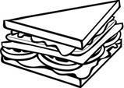When graphed on a coordinate plane, the coordinates of a new kind of triangular slice of bread are (-3, 0), (1, 2), and (5, 2). Where should the baker place her hand while spinning the dough so that the triangle is balanced?
   1. (2, 1)
   2. (1, 0)
   3. (0, 1.5)
   4. (1, 1.5)
3. Two vertices of a parallelogram are A(2, 3) and B(8, 11), and the intersection of the diagonals is X(7, 6). Find the coordinates of the other two vertices.
   1. (12, 9), (6, 1)
   2. (9/2, 9/2), (15/2, 17/2)
   3. (11, 8), (5, 0)
   4. (11/2, 11/2), (17/2, 19/2)

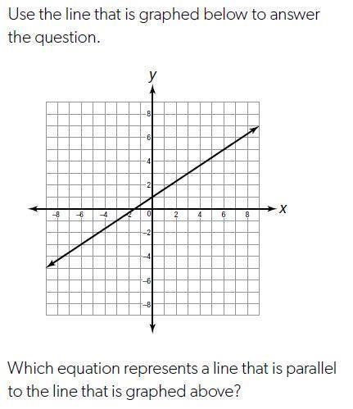

1. Use the line that is graphed to answer the question.

Which equation represents a line that is parallel to

the line graphed?

* 1. 
  2. 
  3. 
  4. 

1. Identify the equation of the line that is perpendicular to x - 4y = 16 and passes through the point (3,1).
   1. y= -4x - 2
   2. y = 1/4 x + 13
   3. y= -4x +13
   4. y = 1/4x - 4

1. Points A(-8, 12) and B(-10, 18) are endpoints of directed line segment AB. What are the coordinates of point P that partitions AB in the ratio 3:2?
   1. (-8.8, 0)
   2. (-8.8, -6)
   3. (-9.2, 0)
   4. (-9.2, 15.6)
2. Find the perimeter of  where  are the vertices of a right triangle. Round to the nearest tenth if needed.
   1. 12.1
   2. 13.8
   3. 11
   4. 10
3. Find the area of square LOVE with vertices: . Round to the nearest tenth if needed.
   1. 9
   2. 8
   3. 18
   4. 64

1. A fitness trainer would like to open a new studio and nutrition juice bar in either Marietta or Athens. (NOTE: Your teacher will score your response to this problem using a 2-point rubric.)

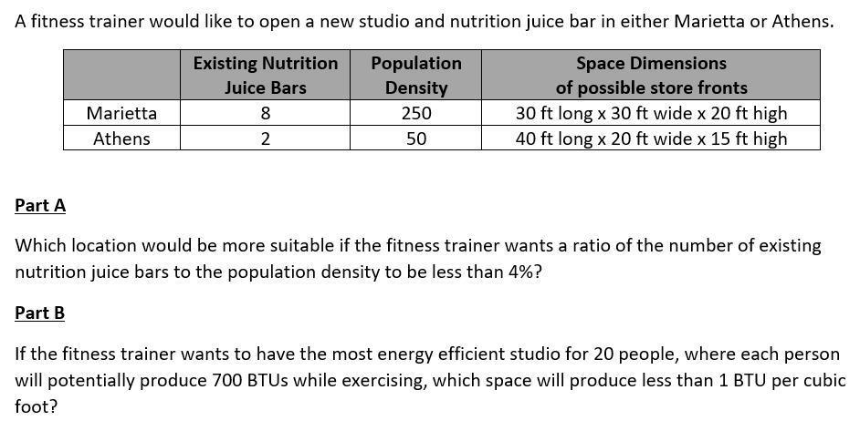

* **Part A:** Which location would be more suitable if the fitness trainer wants a ratio of the number of existing nutrition juice bars to the population density to be less than 4%?
* **Part B:** If the fitness trainer wants to have the most energy efficient studio for 20 people, where each person will potentially produce 700 BTUs while exercising, which space will produce less that 1 BTU per cubic foot?