Name: ____________________________________________________ Date: _______________________________

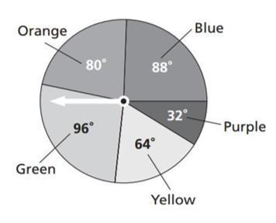

1. What is the probability of the spinner landing on

the orange or purple sector, to the nearest hundredth?

* 1. 0.09
  2. 0.22
  3. 0.31
  4. 0.62

1. 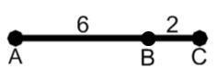A point is chosen randomly on segment AC. What is the probability that the point is NOT on segment AB?
   1. 1/4
   2. 2
   3. 6
   4. 3/4

1. Every human has blood type A, B, O, or AB. 0.1 have type B and 0.46 have type O. What is the probability that someone has type A or AB?
   1. 0.44
   2. 0.48
   3. 0.52
   4. 0.56
2. A person is selected at random. What is the probability that the person was NOT born on a Monday? Express your answer as a percent. If necessary, round your answer to the nearest tenth of a percent.
   1. 14.3%
   2. 20%
   3. 80%
   4. 85.7%
3. Events A and B are independent events. Which statement must be TRUE?
   1. P(A and B) = P(A) · P(B)
   2. P(A and B) = P(A) + P(B)
   3. P( B|A ) = P ( A|B )
   4. P(A) = P(B)
4. Samantha is 1 of 17 students in a class of 85 who have decided to pursue a business degree. Each week, a student in the class is randomly selected to tutor younger students. What is the probability of drawing a business student one week, replacing the name, and drawing the same name the next week?
   1. 0.200
   2. 0.060
   3. 0.040
   4. 0.002

1. Which expression can you use to calculate the conditional probability of event A given that event B has occurred?
   1. 
   2. 
   3. 
   4. 
2. A grab bag contains 8 football cards and 2 basketball cards. An experiment consists of taking one card out of the bag, replacing it, and then selecting another card. Determine whether the events are independent or dependent. What is the probability of selecting a football card and then a basketball card? Express your answer as a decimal.
   1. Dependent; 0.04
   2. Independent; 0.16
   3. Independent; 0.18
   4. Dependent; 0.64
3. A bag contains hair ribbons for a spirit rally. The bag contains 3 black ribbons and 17 green ribbons. Lila and Jessica are drawing from the bag at random. Lila selects a black ribbon, puts it in her hair, and then Jessica selects a green ribbon. Which of the statements is TRUE?
   1. The events are dependent because P(green|black) is different when Lila has already removed one ribbon from the bag and P(green|black) = 51/400.
   2. The events are independent because P(green|black) is same when Lila has already removed one ribbon from the bag and P(green|black)=51/380.
   3. The events are dependent because P(green|black) is different when Lila has already removed one ribbon from the bag and P(green|black) = 51/380.
   4. The events are independent because P(green|black) is same when Lila has already removed one ribbon from the bag and P(green|black)=51/400.

1. 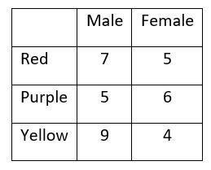The table shows the results of an experiment of spinning a spinner. Using the data from the experiment, what is the probability that a randomly chosen student is a girl given the color was yellow?
   1. 
   2. 
   3. 
   4. 
2. The table shows the distribution of the labor force in the United States in the year 2000. What is the probability that a randomly chosen female works in the industry field?
   1. 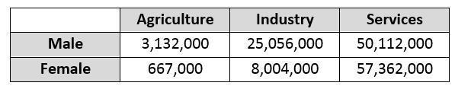0.055
   2. 0.121
   3. 0.242
   4. 0.312
3. A company is testing manufacturing parts using old and new methods. What is the probability that a part chosen at random is new and passed the test?
   1. 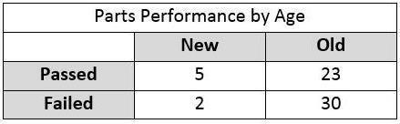0.054
   2. 0.083
   3. 0.147
   4. 0.178
4. To decide if the movie chosen is independent of age, which of the following ratios should be compared?
   1. 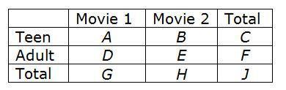
   2. 
   3. 
   4. 
5. 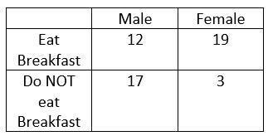Given the data collected in the two-way table, which probability

has the greatest value?

* 1. P(Eat breakast | Male)
  2. P(Eat breakfast | Female)
  3. P(Not eat breakfast | Male)
  4. P(Not eat breakfast | Female)

1. 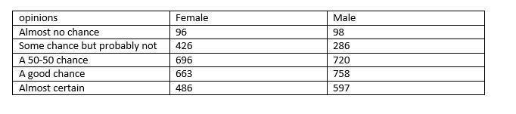If the person selected said "a 50-50 chance," what is the probability that the person was female?
   1. 0.58
   2. 0.29
   3. 0.49
   4. 0.51

1. 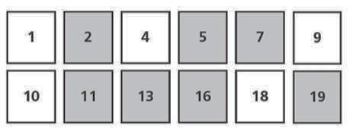You shuffle the cards shown above and choose one at random. What is the probability that you choose a gray card or an even number?
   1. 35/144
   2. 12/19
   3. 5/6
   4. 1

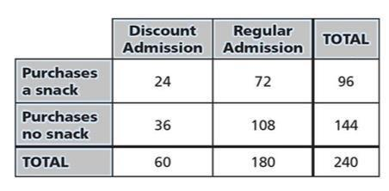

1. What is the probability that a visitor to the movie

theater purchases a snack given that the visitor

pays for a discount admission?

* 1. 0.1
  2. 0.4
  3. 0.25
  4. 0.63

1. 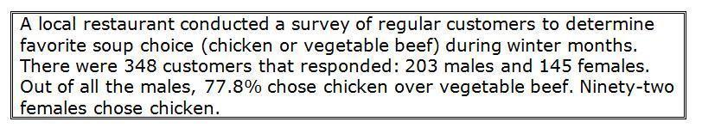What is the probability that a customer selected at random will choose vegetable beef soup?
   1. 22.2%
   2. 28.2%
   3. 30.2%
   4. 58.2%
2. Consider the following events.

Event A: You passed your statistics class.

Event B: You failed your statistics class.

Which term describes the two events?

* 1. Dependent events
  2. Independent events
  3. Overlapping events
  4. Mutually exclusive events

1. 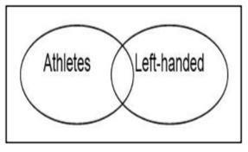Of 50 students going on a class trip, 35 are student athletes and 45 are right-handed. Three student athletes are left-handed. What is the probability that one of the students on the trip is an athlete or is left-handed?
   1. 0.20
   2. 0.50
   3. 0.74
   4. 0.80

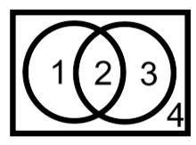

1. The Venn diagram will be shaded to model the different

probabilities associated with Events A and B. Which

regions should be shaded to represent the model used to

determine P(A or B?

* 1. Regions 1, 2, 3, and 4
  2. Regions 1, 2, and 3
  3. Region 1 and 3
  4. Region 2

1. Which pair of events is mutually exclusive?
   1. Rolling 2 dice and getting an even sum or a sum of 6.
   2. Picking an Ace or a Heart from a deck of cards.
   3. Rolling 2 dice and getting an even sum or getting a sum of 7.
   4. Picking a Face card or a Queen from a deck of cards.
2. If P(A)=62.9%, P(B)=45.2%, and P(A and B)=21%, what is the probability of A or B?
   1. 21.0%
   2. 66.1%
   3. 75.9%
   4. 87.1%
3. 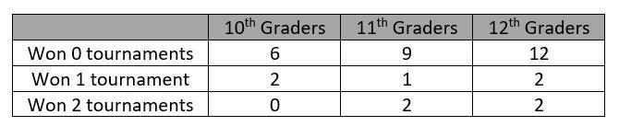There are 10th-grade, 11th-grade, and 12th-grade students in a high school chess club. The table above shows the number of students by grade level based on the number of tournaments won. (NOTE: Your teacher will score your response to this question using a 4-point rubric.)

* **Part A**: What is the probability that a randomly chosen student won 2 tournaments given that he or she is a 12th-grader?
* **Part B**: What is the probability that a randomly chosen student is a 12th-grader given that he or she won at least 1 tournament?
* **Part C**: Let A represent the event that a randomly chosen student won 0 tournaments. Let B represent the event that a student is a 10th-grader.

Calculate the P(A), P(B), and P(A and B).

* **Part D**: The president of the chess club says that events A and B are independent. Explain why this is true. Show your calculations.